1.The values of W and b for different fold of the 10 fold stratified cross validation are shown in the table :

|  |  |  |
| --- | --- | --- |
| b | w0 | w1 |
| -0.0665 | -1.5406 | -0.8987 |
| -0.0665 | -1.5406 | -0.8987 |
| -0.0665 | -1.5406 | -0.8987 |
| -0.0665 | -1.5406 | -0.8987 |
| -0.0665 | -1.5406 | -0.8987 |
| -0.0665 | -1.5406 | -0.8987 |
| 0.0030 | -0.9688 | -0.10436 |
| -0.0867 | -1.5514 | -0.8743 |
| -0.0665 | -1.5406 | -0.8987 |
| -0.0328 | -1.4920 | -0.8704 |

**Time for each fold** = [0.1354 0.1147 0.1238 0.1310 0.1290 0.1289 0.1177 0.1141 0.1395 0.1178]

**Error for each fold** = [0 0 0 0 0 0 0 0 0 0]

**Average Accuracy** = 100% **Average Time** = 0.1252 seconds.

**1(b):**

The plot of the point along with the hyperplane separating the points of different classes :

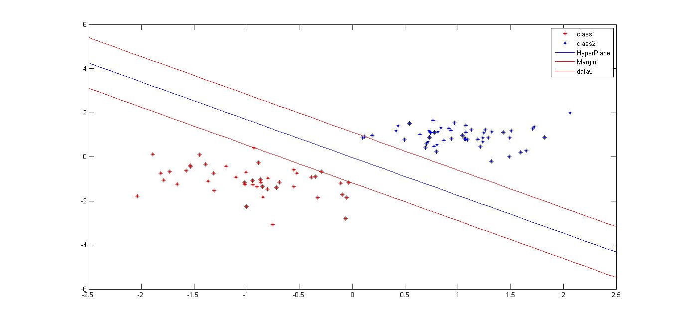

**1(c) :**

**Avarage training time for classifier : Average Time** = 0.1252 seconds.

**Time for each fold** = [0.1354 0.1147 0.1238 0.1310 0.1290 0.1289 0.1177 0.1141 0.1395 0.1178]

2.

(b) SVM with Quadratic Kernel is trained on the dataset2 . The resultant hyperplane,margin and support vector is shown in the diagram :

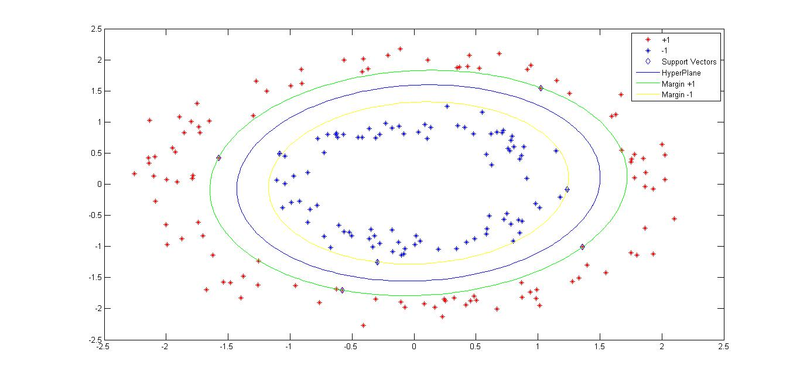

(c) 10 fold Stratified Cross validation is implemented for both Linear Kernel and Quadratic kernel with C= 1 ,the results are :

**Linear Kernel** :

**Time for each fold** = [0.5374 0.4030 0.3916 0.5159 0.3603 0.5273 0.3759 0.5371 0.4061 0.3640]

**Error for each fold** = [70 55 55 55 50 60 60 30 55 45]

**Average Error** = 46.5000% **Average Time** = 0.4999seconds.

**Quadratic Kernel** :

**Time for each fold** = [0.6258 0.6570 0.6180 0.6141 0.6756 0.6267 0.6059 0.5533 0.6191 0.5302]

**Error for each fold** = [0 0 0 0 0 0 0 0 0 0]

**Average Accuracy** = 100% **Average Time** = 0.6126 seconds.

3. The Implementation of SVM in 2 and the inbuilt SVM of MATLAB with SMO without is trained on

Comparison of SVM and Implementation of SVM in 2 Table

|  |  |  |
| --- | --- | --- |
|  | SVM (IN Built) | SVM Implemented |
| Average Time (s) | 0.4114 | 286.23 |
| Average Accuracy | 99.95 | 99.90 |

4. The comparison of the SVm and MLP on the data is given as :

The Values for the SVM are

|  |  |  |
| --- | --- | --- |
| BoxConstraint | Sigma | Accuracy |
| 0.001 | 0.001 | 10 |
| 0.01 | 10 | 18.36 |
| 10 | 100 | 19.74 |
| 100 | 1000 | 19.78 |
| 1000 | 100 | 19 |